SIMATS ENGINEERING (SAVEETHA SCHOOL OF ENGINEERING)
Department of Computer Science and Engineering

CO2 ASSESSMENT TOOL 2 – Architecture Design Assignment

Course Code: | CSA1022 | Course Title: | Software Engineering
CO Assessed: | CO2 | Assessment: | Assessment Tool 2 – Architecture Design Assignment
Weightage: | 20% | Total Marks: | 25
CO2 Statement: | Perform detailed requirements analysis, design scalable architectures, and prioritize features with a focus on cross-disciplinary skills
Student Name: | Keerthana R | Reg. No.: | 192524489
Date: | 30-10-26 | Duration: | 60 minutes

Code of Conduct
I ___Keerthana R(192524489)_____ (Name / Reg No) certify that this submission is my original work and that I have adhered to the guidelines specified for this assessment. I understand that any violation of academic integrity rules will result in disciplinary action.
Signature of the Student: ___KEERTHANA R________
Annexure A – Architecture Design Assignment

Instructions to Students:
Each student will be assigned an individual software project problem statement. Based on the assigned problem, analyze the system requirements and design an appropriate software architecture by applying software engineering principles. Your submission should demonstrate your ability to select, justify, and evaluate a suitable architectural style.
Question
Based on your assigned problem statement, perform an Architecture Design Analysis and prepare an architecture design report by answering the following questions:
- Analyze System Requirements
  - Study the given problem statement and identify the system objectives.
  - Analyze the functional and non-functional requirements that influence the software architecture.
  - Identify key quality attributes such as scalability, maintainability, reliability, availability, performance, and security.
- Select a Suitable Software Architecture
  - Select an appropriate architectural style for the proposed system (e.g., Layered Architecture, Client-Server, MVC, Microservices, Event-Driven, Service-Oriented Architecture, Serverless, or Hybrid Architecture).
  - Justify why the selected architecture is the most suitable for the given problem.
- Draw the Software Architecture Diagram
  - Design a clear architecture diagram illustrating the overall structure of the proposed system.
  - Include all major layers/components, databases, external systems, APIs, and communication mechanisms.
  - Use appropriate software architecture notations and labels.
- Explain Components and Their Interactions
  - Describe the purpose and responsibilities of each architectural component.
  - Explain how the components communicate and exchange data.
  - Illustrate the overall workflow of the system.
- Discuss Quality Attributes
Evaluate how the proposed architecture addresses the following aspects:
  - Scalability
  - Security
  - Performance
  - Reliability
  - Maintainability
  - Availability
- Justify Architectural Decisions
  - Explain the rationale behind your architectural choices.
  - Discuss the trade-offs considered while selecting the architecture.
  - Explain how the chosen architecture supports future enhancements, system integration, and long-term maintainability.
Evaluation Criteria | Excellent (4 Marks) | Good (3  Marks) | Satisfactory (2  Marks) | Needs Improvement  Mark)
System Requirement  Analysis (30%) | Thoroughly analyzes the problem statement, accurately identifies functional and non-functional requirements, and clearly explains quality attributes influencing the architecture. | Analyzes most requirements with minor omissions or  limited explanation. | Identifies only basic requirements with partial analysis. | Requirement analysis is i inaccurate, or lacks clarit
Selection of Software  Architecture (25%) | Selects the most appropriate architectural style with strong technical justification aligned to system requirements. | Selects a suitable architecture with reasonable justification. | Architecture is partially suitable with limited justification. | Inappropriate architecture or justification is missing
Architecture Diagram and  Component Design (20%) | Produces a clear, complete, and well-structured architecture diagram with all major components, interfaces, and interactions accurately represented. | Diagram is mostly complete with minor omissions or notation issues. | Diagram includes only essential components and lacks sufficient detail. | Diagram is incomplete, u technically incorrect.
Component Interaction and Quality Attribute  Analysis (15%) | Clearly explains component responsibilities, interactions, and thoroughly discusses scalability, security, performance, reliability, maintainability, and availability. | Explains most components and  quality attributes with minor gaps. | Provides limited explanation of interactions and addresses only some quality attributes. | Component interactions attributes are poorly expl missing.
Criteria | Mark
System Requirement Analysis (30%) | /5
Selection of Software Architecture (25%) | /5
Architecture Diagram and Component Design (20%) | /5
Component Interaction and Quality Attribute Analysis (15%) | /5
Architectural Justification and Technical Presentation (10%) | /5
TOTAL | /25
Rubrics for Calculation
ab

Architectural Justification and Technical Presentation  (10%) | Provides strong justification for architectural decisions, discusses trade-offs and future enhancements, and presents a well-organized, professional report. | Provides adequate justification with minor gaps; report is well organized. | Limited justification with minimal discussion of trade-offs or future scope; report needs improvement. | Justification is weak or report lacks organization technical clarity.

Decentralized Software Supply Chain Integrity & Automated Vulnerability Guard

Industry Context: Modern software engineering depends heavily on open-source libraries
and complex dependency trees. Cybercriminals increasingly target this reliance
by injecting malicious code into upstream packages (software supply chain
attacks), which then slip silently into enterprise production systems.
Developers need a continuous security platform that evaluates the integrity of
code dependencies, verifies cryptographic signatures, and stops vulnerable
builds automatically before deployment.
Problem Statement: Design and develop an end-to-end Software Supply Chain Integrity
Platform that continuously monitors, validates, and charts every code artifact
and dependency across an organization's CI/CD pipelines. The platform must
ingest package manager files, container configuration configurations, and
developer cryptographic signatures across thousands of code repositories. It
must build dynamic dependency graphs, cross-reference them with global
vulnerability repositories, and block unsafe deployments automatically.
Objectives:
Construct real-time, multi-layered software bill of materials (SBOM) graphs for all
enterprise builds.
Verify cryptographic provenance signatures for open-source code artifacts
automatically.
Execute lightning-3 fast, concurrent cross-references against live vulnerability data
structures.
Implement automated, deep code patches for known nested dependency vulnerabilities during
build execution.
Block malicious container image build execution profiles inside CI/CD engines.

Expected Outcomes:
Absolute elimination of vulnerable open-source code slipping into production systems.
Drastic reduction in manual developer patching efforts via automated deep dependency
updates
Total visibility into the licensing and security health of vast software code
portfolios.
Full compliance with international government security regulations for software
procurement.

1. Introduction
Modern software development depends heavily on open-source libraries, third-party packages, container images, and automated CI/CD pipelines. Although these technologies accelerate development, they also introduce security risks. Attackers may compromise upstream packages, inject malicious code, publish vulnerable dependencies, or distribute container images with unsafe configurations.
Traditional security testing often focuses on the application's source code and may not provide complete visibility into nested dependencies or the origin of software artifacts. A vulnerability hidden several dependency levels deep can enter a production environment without being noticed.
The Software Supply Chain Integrity & Automated Vulnerability Guard is proposed as an end-to-end security platform that continuously monitors software dependencies, verifies cryptographic provenance, identifies vulnerabilities, generates Software Bill of Materials (SBOMs), and prevents unsafe builds from reaching deployment.
The platform integrates with enterprise repositories and CI/CD pipelines to provide centralized visibility into software components, licensing information, security risks, and artifact integrity.
Problem statement
To design and develop an end-to-end Software Supply Chain Integrity Platform that continuously monitors, validates, and tracks every code artifact and dependency across an organization's CI/CD pipelines.
The platform must ingest package manager files, container configurations, and developer cryptographic signatures from thousands of repositories. It must construct dynamic dependency graphs, cross-reference dependencies against global vulnerability databases, automatically remediate known nested dependency vulnerabilities where safe, and block malicious or vulnerable build execution profiles before deployment.
Objectives
The main objectives are:

- Real-time SBOM generation: Construct multi-layered Software Bill of Materials graphs for enterprise builds.
- Cryptographic provenance verification: Verify the authenticity and integrity of open-source artifacts using digital signatures.
- Concurrent vulnerability detection: Cross-reference dependencies against vulnerability databases such as NVD, OSV, and GitHub Security Advisories.
- Automated dependency remediation: Identify vulnerable nested dependencies and generate safe dependency updates or patches.
- Container security enforcement: Detect unsafe container configurations and block builds that violate security policies.
- Continuous monitoring: Track security, licensing, and integrity information across repositories.
- Automated deployment protection: Prevent builds from proceeding when critical security policies are violated.
- Audit and reporting: Maintain historical records of scans, vulnerabilities, signatures, patches, and deployment decisions.

Important design clarification: Absolute elimination of vulnerable code cannot be guaranteed by a software architecture. The platform aims to reduce risk through continuous detection, verification, remediation, and enforcement. Similarly, regulatory compliance requires organizational controls and audits in addition to technical features.

- Analyse System Requirements

2.1 Functional Requirements
Functional requirements describe the operations that the proposed platform must perform.
ID | Functional requirement | Description
FR1 | Repository integration | Connect with multiple source-code repositories such as GitHub and GitLab.
FR2 | Build configuration ingestion | Collect package files such as package. Json, requirements.txt, pom.xml, and container configuration files.
FR3 | SBOM generation | Generate an SBOM for every scanned build.
FR4 | Dependency graph construction | Identify direct and transitive dependencies and represent their relationships as a graph.
FR5 | Signature verification | Verify cryptographic signatures and artifact provenance.
FR6 | Vulnerability scanning | Compare dependency versions with external vulnerability databases.
FR7 | Risk assessment | Calculate risk levels based on vulnerability severity, exploitability, and policy rules.
FR8 | Automated remediation | Recommend or generate dependency upgrades and patches for known vulnerabilities.
FR9 | Container security scanning | Inspect container images, Docker files, and build configurations for unsafe practices.
FR10 | CI/CD policy enforcement | Block builds or deployments that violate defined security policies.
FR11 | Dashboard and reporting | Display vulnerabilities, SBOMs, licenses, provenance status, and remediation progress.
FR12 | Audit logging | Store scan results, patch decisions, signature checks, and build-blocking events.
FR13 | Authentication and authorization | Ensure that only authorized users and services access the platform.
FR14 | Continuous monitoring | Re-scan dependencies when vulnerability intelligence or repository contents change.

2.2 Non-functional requirements

Non-functional requirements define how effectively and securely the platform must operate.

Requirement | Description
Performance | Perform concurrent vulnerability checks and dependency analysis with low processing latency.
Scalability | Support thousands of repositories and large dependency graphs.
Reliability | Ensure scan results and security decisions are processed consistently.
Availability | Keep repository monitoring, scanning, and policy enforcement services available.
Security | Protect source-code metadata, artifacts, credentials, signatures, and user accounts.
Maintainability | Allow individual services to be updated and tested independently.
Interoperability | Integrate with different source repositories, package managers, registries, and CI/CD tools.
Data integrity | Preserve accurate SBOMs, provenance records, and vulnerability results.
Fault tolerance | Handle failures in scanners, message brokers, databases, and external vulnerability feeds.
Usability | Provide a clear dashboard with understandable risk levels and remediation recommendations.

Quality Attributes Influencing Architecture
- Scalability: The system must process repositories and dependency graphs in parallel.
- Performance: Vulnerability matching and signature verification should avoid unnecessary delays in build pipelines.
- Security: Cryptographic verification, encrypted communication, authentication, and access control are essential.
- Reliability: Scanning failures must not be interpreted as successful security checks.
- Availability: Critical scanning and policy services should have backup instances.
- Maintainability: Separate services should make it easier to introduce new scanners, package managers, and vulnerability sources.

System Constraints and Assumptions
- The platform receives repository and build information through authenticated APIs or CI/CD agents.
- Package manager files and container configurations are available during the build process.
- External vulnerability databases may have API limits or temporary outages.
- Cryptographic signatures and trusted identities are available for artifacts that require provenance verification.
- Automated patches must be tested before being accepted.
- CI/CD systems support build-gate integration or deployment approval checks.
- Security policies and vulnerability severity thresholds are configured by administrators.

3.Selection of Suitable Software Architecture
Selected Architecture: Hybrid Microservices and Event-Driven Architecture
The proposed platform uses a Hybrid Microservices and Event-Driven Architecture, supported by a layered design.
This architecture combines independently deployable microservices with asynchronous event communication. Each major security function operates as a separate service, while a message broker distributes repository events, scan requests, vulnerability updates, and remediation results.
The layered design organizes the presentation, API, business logic, processing, and storage responsibilities.
Microservices architecture
The platform is divided into services such as:
- Repository Integration Service
- SBOM Generation Service
- Dependency Graph Service
- Signature Verification Service
- Vulnerability Intelligence Service
- Risk Assessment Service
- Automated Remediation Service
- Container Security Service
- CI/CD Policy Enforcement Service
- Audit and Reporting Service
Event-driven architecture
Events are published when a repository changes, a build starts, a scan completes, a vulnerability is discovered, or a remediation is approved.
A message broker distributes these events to the relevant services without requiring every component to communicate synchronously.
Why This Architecture Is Suitable
- High concurrency: Multiple repositories and builds can be scanned simultaneously.
- Independent scaling: Resource-intensive vulnerability and SBOM services can scale separately.
- Low coupling: Services communicate through defined APIs and events.
- Fault isolation: Failure in the reporting service does not need to stop dependency scanning.
- Easy integration: APIs and event messages support different repositories and CI/CD platforms.
- Maintainability: Individual security modules can be upgraded independently.
- Future expansion: new vulnerability sources, scanners, and AI-based analysis modules can be added without redesigning the entire platform.

Comparison with Other Architectures

Architecture | Limitation for this project
Monolithic | All functions are tightly connected, making independent scaling and maintenance difficult.
Layered only | Organizes the application but does not by itself provide an effective solution for large asynchronous scanning workloads.
Client-Server | Supports centralized access but does not fully address distributed scanning and event processing.
Serverless only | Can be useful for selected event tasks, but execution limits and workload characteristics make it less suitable as the sole architecture for continuous scanning and enforcement.
Microservices + Event-Driven | Supports independent scaling, asynchronous processing, integration, and fault isolation.
Therefore, the hybrid architecture is selected because it directly addresses the platform's large-scale repository monitoring, concurrent scanning, vulnerability processing, and automated CI/CD enforcement requirements.

Software Architecture Diagram
It includes the major architectural layers, microservices, message broker, databases, external systems, and communication mechanisms.

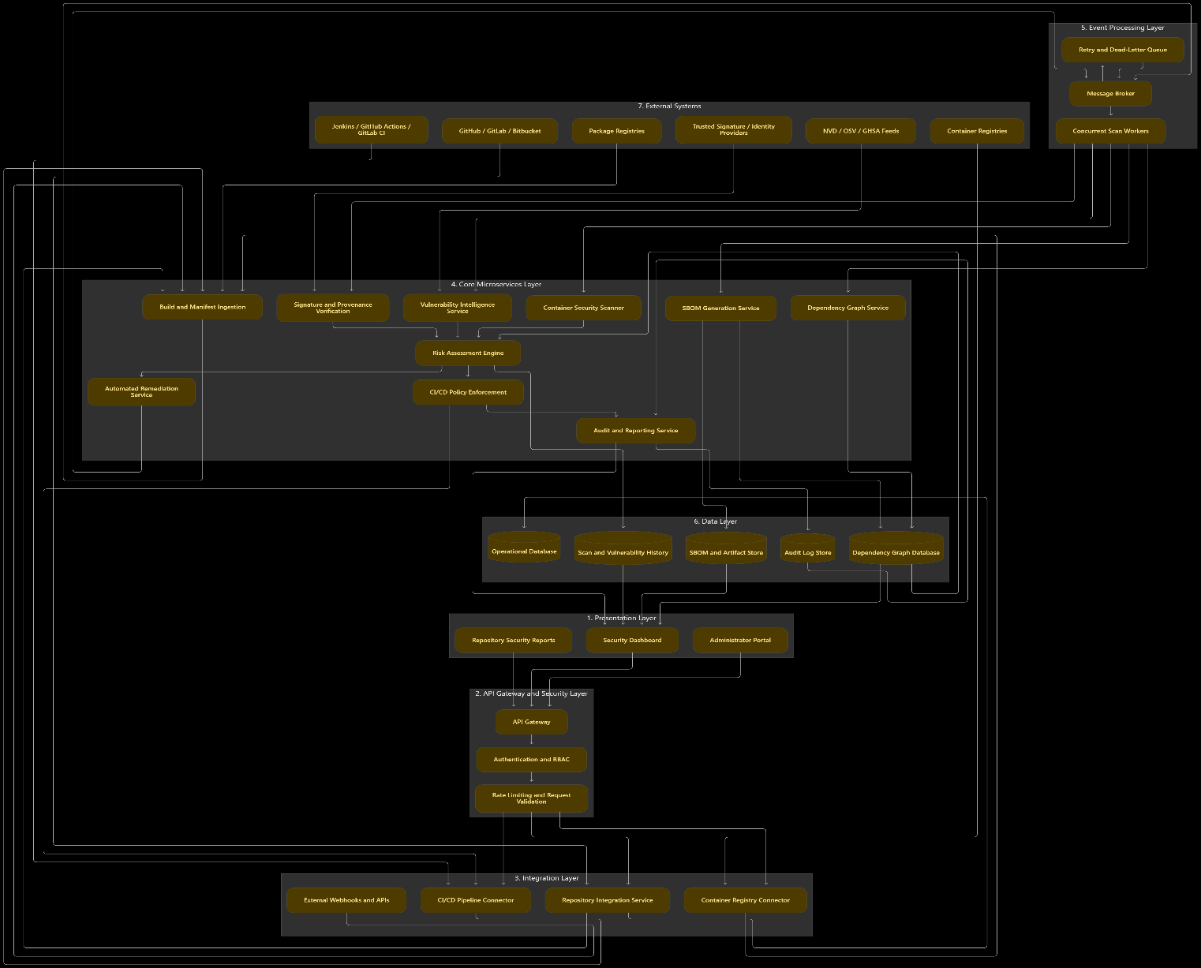
Figure 1. Proposed hybrid microservices and event-driven software architecture

Explanation this diagram:
- The presentation layer allows developers and administrators to view security information.
- The API gateway provides a controlled entry point for requests.
- The integration layer connects repositories, CI/CD pipelines, and container registries.
- The microservices layer performs SBOM generation, dependency analysis, signature verification, vulnerability detection, remediation, and policy enforcement.
- The event processing layer distributes tasks to concurrent workers.
- The data layer stores dependency relationships, SBOMs, scan history, and audit records.
- External systems provide source code, packages, signatures, and vulnerability intelligence.

Dependency Graph Diagram
This is an important additional diagram because your problem statement specifically mentions dynamic, multi-layered dependency graphs.
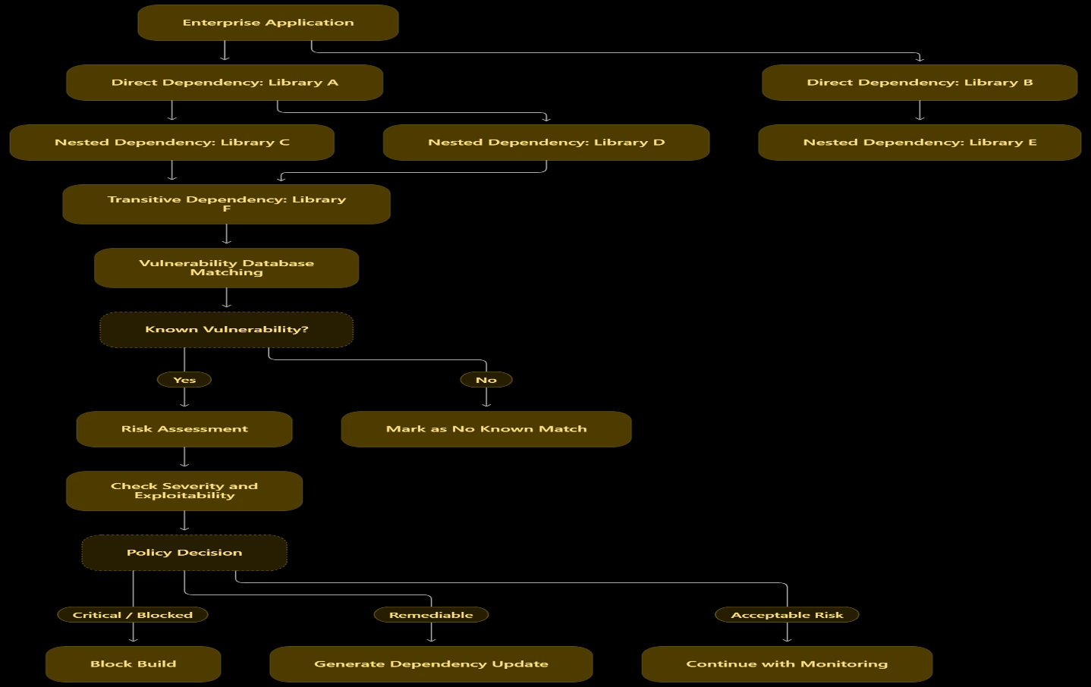
Figure 2. Multi-level dependency graph and vulnerability assessment.

Explanation:
The platform identifies direct, nested, and transitive dependencies. Each dependency becomes a node, and each dependency relationship becomes an edge. The graph is then checked against vulnerability intelligence sources.
For example, an application may not directly use Library F, but Library F may be included through Library C or Library D. The graph helps identify this hidden dependency and determine whether it introduces a security risk.

4.Explanation of Components and Their Responsibilities

4.1 Repository Integration Service
Purpose: Connects the platform with source-code repositories.
Responsibilities:
- Integrates with GitHub, GitLab, and Bitbucket.
- Monitors repository commits and pulls requests.
- Receives webhook notifications.
- Collects package manager manifests and build metadata.
- Initiates security scans when repository changes occur.
4.2 Build and Manifest Ingestion Service
Purpose: Collects software dependency and container configuration information.
Responsibilities:
- Reads package. Json, requirements.txt, pom.xml, and similar files.
- Collects Docker files and container build configurations.
- Validates uploaded files and metadata.
- Identifies package names, versions, and dependency declarations.
- Sends scan requests to the event processing layer.

4.3 SBOM Generation Service
Purpose: Creates a Software Bill of Materials for each build.
Responsibilities:
- Identifies software components and their versions.
- Records direct and transitive dependencies.
- Captures package identifiers and licensing information.
- Generates standardized SBOM documents.
- Stores SBOM records for future comparison.
Suggested standards: CycloneDX and SPDX.
An SBOM provides a structured inventory of the components used in a software application.
Dependency Graph Service
Purpose: Constructs and maintains dependency relationships.
Responsibilities:
- Builds multi-level dependency graphs.
- Identifies nested and transitive dependencies.
- Detects dependency conflicts and duplicate versions.
- Tracks dependency changes between builds.
- Provides graph information to the vulnerability analysis service.
Suggested algorithms and techniques:
- Directed graph representation.
- Depth-First Search (DFS) for dependency traversal.
- Breadth-First Search (BFS) for level-wise dependency exploration.
- Graph indexing for efficient dependency lookup.

4.5 Signature and Provenance Verification Service
Purpose: Verifies the authenticity and origin of software artifacts.
Responsibilities:
- Validates cryptographic signatures.
- Checks artifact hashes against expected values.
- Verifies trusted signing identities.
- Checks provenance metadata and build origin.
- Flags unsigned, tampered, or untrusted artifacts.
Suggested technologies: Sigstore Cosign, in-toto, and cryptographic hashing such as SHA-256.

4.6 Vulnerability Intelligence Service
Purpose: Identifies known security vulnerabilities in software dependencies.
Responsibilities:
- Retrieves vulnerability information from external databases.
- Matches package identifiers and versions.
- Identifies affected and fixed version ranges.
- Updates vulnerability information periodically.
- Publishes vulnerability alerts to the risk assessment engine.
Suggested sources:
- NVD – National Vulnerability Database.
- OSV – Open Source Vulnerabilities.
- GitHub Security Advisories.

4.7 Risk Assessment Engine
Purpose: Evaluates the security risk of each build.
Responsibilities:
- Combines vulnerability severity, exploitability, provenance status, and policy rules.
- Identifies critical and high-risk dependencies.
- Detects policy violations.
- Classifies builds as approved, requiring remediation, or blocked.
- Sends the final security decision to the CI/CD enforcement service.
A possible conceptual risk model is:
\[ R = w_1V + w_2P + w_3S + w_4C \]
Where:
- \(V\) = vulnerability severity.
- \(P\) = provenance or signature risk.
- \(S\) = exploitability or exposure.
- \(C\) = container configuration risk.
- \(w_1,w_2,w_3,w_4\) = configurable weights.
The model is a proposed scoring approach; actual weights and thresholds must be defined and tested. Some policy violations, such as a confirmed malicious artifact, should trigger a hard block regardless of the numerical score.

4.8 Automated Remediation Service
Purpose: Reduces manual effort when vulnerable dependencies are discovered.
Responsibilities:
- Identifies vulnerable direct and nested dependencies.
- Searches for safe compatible versions.
- Generates dependency updates or patch proposals.
- Creates automated pull requests where supported.
- Runs tests and vulnerability rescans.
- Sends unsuccessful or uncertain updates for developer review.
Important: The service must not blindly modify dependency files. It should preserve compatibility, validate changes, run tests, and require approval when a safe automatic fix cannot be established.

4.9 Container Security Scanner
Purpose: Detects unsafe container images and build configurations.
Responsibilities:
- Scans container images for vulnerable packages.
- Inspects Docker files and container configurations.
- Identifies unsafe privileges and risky configuration patterns.
- Checks image provenance and integrity.
- Reports policy violations before deployment.

4.10 CI/CD Policy Enforcement Service
Purpose: Controls whether a build can continue to the next stage.
Responsibilities:
- Receives the security decision from the risk engine.
- Applies administrator-defined policies.
- Blocks builds that violate mandatory security requirements.
- Approves builds that pass the security checks.
- Sends notifications to developers and administrators.
- Records build-gate decisions.
4.11 Message Broker and Concurrent Processing Service
Purpose: Supports asynchronous communication and large-scale scanning.
Responsibilities:
- Receives scan and repository events.
- Distributes jobs to independent workers.
- Processes multiple repositories concurrently.
- Buffers tasks during temporary service failures.
- Supports retry mechanisms and dead-letter queues.
Suggested technologies: Apache Kafka or RabbitMQ.
4.12 Database and Audit Service
Purpose: Stores system information and maintains traceability.
Storage component | Data stored
Operational database | Repository details, users, build information, policies
Dependency graph database | Packages and dependency relationships
SBOM and artifact store | Generated SBOM files and artifact metadata
Scan history database | Vulnerability findings and scan results
Audit log store | Signature checks, remediation decisions, build approvals and blocks

4.13 Security Dashboard
Purpose: Provides centralized visibility into software supply chain security.
The dashboard displays:
- Total repositories monitored.
- Total dependencies identified.
- Vulnerabilities by severity.
- Signature verification status.
- License compliance information.
- Container image security status.
- Automated patch progress.
- Blocked and approved builds.
- Historical audit reports.

5.Overall System Workflow
The complete workflow is as follows:
- Repository connection: The platform connects to enterprise repositories and CI/CD pipelines.
- Build event detection: A new commit, pull request, or build triggers a scan.
- Manifest ingestion: Package manager files and container configurations are collected.
- SBOM generation: The platform creates a software component inventory.
- Dependency graph construction: Direct, nested, and transitive dependencies are mapped.
- Signature verification: Artifact signatures and provenance records are validated.
- Vulnerability scanning: Dependencies are matched against vulnerability databases.
- Container inspection: Container images and build profiles are checked for unsafe configurations.
- Risk assessment: The engine evaluates the findings against security policies.
- Automated remediation: Eligible vulnerabilities receive proposed dependency upgrades or patches.
- Testing and rescanning: Remediated builds are tested and scanned again.
- CI/CD enforcement: The platform approves or blocks the build based on the policy decision.
- Audit and reporting: Results are stored and displayed on the security dashboard.

Example Scenario
Suppose an enterprise application uses Library A, and Library A depends on Library B. A new vulnerability is reported in the installed version of Library B.
The proposed platform:
- Identifies Library B through the dependency graph.
- Matches its version with vulnerability intelligence.
- Determines the vulnerability severity and affected version range.
- Checks whether a fixed version is available.
- Generates a dependency update proposal.
- Runs compatibility and security tests.
- Rescans the updated dependency graph.
- Approves the build only if the required policies pass.
If no safe remediation is available, the platform blocks the build or sends it for an authorized security exception.

6. Quality Attribute Analysis
This section is important because the rubric specifically evaluates how the architecture addresses six quality attributes.

6.1 Scalability
Scalability is the ability of the platform to handle increasing workloads.
Design approach:
- Deploy microservices as independent instances.
- Use horizontal scaling for vulnerability scanning workers.
- Partition repository and scan events across message broker topics.
- Process dependency graphs concurrently.
- Use distributed storage for SBOMs and historical scan records.
- Apply load balancing across service instances.
Evaluation: The architecture supports thousands of repositories by allowing resource-intensive services to scale independently. Actual capacity must be established through load testing.

6.2 Security
Security protects the platform, software artifacts, and sensitive repository information.
Design approach:
- Use TLS encryption for communication.
- Implement role-based access control.
- Verify artifact signatures and provenance.
- Use secure credential and secret management.
- Validate repository inputs and uploaded manifests.
- Encrypt sensitive stored information.
- Maintain audit logs for security-related activities.
- Apply least-privilege access to CI/CD agents and scanning services.
Evaluation: Multiple security controls reduce the possibility of unauthorized access, tampering, and malicious artifact execution.

6.3 Performance
Performance ensures that security checks do not unnecessarily delay software development.
Design approach:
- Use asynchronous event processing.
- Run vulnerability scans concurrently.
- Cache frequently accessed vulnerability information with freshness controls.
- Use indexed dependency graphs.
- Avoid repeated analysis of unchanged dependencies where safe.
- Separate scanning workloads from dashboard queries.
Evaluation: Parallel processing and caching can reduce scanning time. Performance should be measured using scan latency, throughput, and build-gate response time.

6.4 Reliability
Reliability ensures that security operations produce consistent and trustworthy results.
Design approach:
- Validate manifests and scan inputs.
- Use message retries and dead-letter queues.
- Maintain scan history and audit records.
- Use idempotent event processing to prevent duplicate operations.
- Detect incomplete or failed scans.
- Prevent failed security checks from being treated as successful checks.
- Test automated patches before accepting them.
Evaluation: Failure detection and recovery reduce the risk of incorrect security decisions. An unavailable vulnerability database or scanner should produce an explicit incomplete or failed status rather than a clean result.

6.5 Maintainability
Maintainability is the ability to modify, debug, and improve the platform.
Design approach:
- Divide the system into independent microservices.
- Use documented and versioned APIs.
- Maintain standard event formats.
- Automate unit, integration, and regression testing.
- Use CI/CD for platform updates.
- Keep configuration separate from application code.
- Maintain technical documentation.
Evaluation: Independent services make it easier to add new vulnerability sources, package managers, and security scanning features. Distributed services require additional monitoring and integration testing.
Availability
Availability ensures that essential platform services remain accessible.
Design approach:
- Deploy critical services with redundant instances.
- Use health checks and automatic recovery.
- Replicate important databases and message broker data.
- Maintain backup and disaster recovery procedures.
- Monitor external vulnerability feed availability.
- Support safe fallback policies during external service failures.
Evaluation: Redundancy reduces downtime. However, if critical security intelligence is unavailable, the system should apply a predefined fail-closed or manual-review policy instead of automatically approving an unverified build.

6.7 Quality Attribute Summary
Quality attribute | Supporting mechanism | Verification method
Scalability | Horizontal scaling and concurrent workers | Load testing
Security | TLS, RBAC, signature verification | Security testing
Performance | Event processing and caching | Latency testing
Reliability | Retries, validation, fault handling | Fault-injection testing
Maintainability | Modular services and versioned APIs | Integration and regression testing
Availability | Replication and failover | Recovery testing

7.Architectural Justification
7.1 Major Architectural Decisions
Architectural decision | Justification
Microservices | Allows independent development, deployment, and scaling of security functions.
Event-driven communication | Handles large numbers of repository and scanning events asynchronously.
API Gateway | Provides a controlled entry point for repositories, users, and CI/CD integrations.
Message Broker | Distributes scanning tasks to multiple workers concurrently.
Dependency Graph | Identifies direct and hidden nested dependencies.
SBOM generation | Provides visibility into all software components and licenses.
Signature verification | Validates artifact authenticity and provenance.
Separate data stores | Supports different storage and querying requirements for graphs, SBOMs, scans, and audit records.
Automated CI/CD gate | Prevents builds from progressing when mandatory security policies fail.
Centralized monitoring | Provides visibility into security health and system failures.

Trade-offs Considered
Every architecture introduces certain benefits and limitations.
Benefit | Trade-off
Independent service scaling | Requires service orchestration and distributed monitoring.
Asynchronous event processing | May introduce delays, duplicate events, and eventual consistency.
Concurrent vulnerability scanning | Requires computing resources and efficient workload management.
Automated dependency patching | May introduce compatibility issues or unexpected application failures.
Detailed SBOM generation | Requires additional processing and storage.
High availability | Increases infrastructure and maintenance costs.
External vulnerability intelligence | Depends on external database availability and update frequency.
Strict CI/CD enforcement | May delay builds when security services are unavailable or produce uncertain results.

7.3 Future Enhancements
The architecture can support several future improvements:
- AI-based vulnerability prioritization: Use intelligent models to prioritize vulnerabilities based on exploitability and application context.
- Predictive dependency risk analysis: Identify potentially risky dependencies before vulnerabilities are publicly reported.
- Advanced automated remediation: Improve compatibility analysis and generate safer nested dependency updates.
- Zero-trust software supply chain: Strengthen identity verification and access control for every software artifact and pipeline.
- Advanced license compliance: Automatically identify license conflicts and generate compliance reports.
- Digital provenance tracking: Maintain verifiable records of software creation, modification, and distribution.
- Multi-cloud integration: Support repositories and deployment environments across multiple cloud platforms.
- Advanced analytics: Provide enterprise-level security trends and risk reports across thousands of repositories.

Proposed Technology Stack
The following technologies are suitable choices for implementing an academic prototype and can also be extended for enterprise use.
Layer | Suggested technology | Purpose
Frontend | React.js | Security dashboard
Backend | Python Fast API | REST APIs and microservices
Database | PostgreSQL | Users, repositories, policies, build records
Graph storage | Neo4j | Dependency graph relationships
Message broker | RabbitMQ or Kafka | Asynchronous event processing
SBOM generation | Syft | Software inventory generation
Vulnerability scanning | Grype / Trivy | Dependency and container scanning
Signature verification | Sigstore Cosign | Container and artifact signature verification
Provenance | in-toto | Supply chain provenance verification
Vulnerability sources | OSV / NVD / GHSA | Vulnerability intelligence
Containerization | Docker | Packaging services
Orchestration | Kubernetes | Deployment and scaling
Monitoring | Prometheus and Grafana | Metrics and system monitoring
Version control | GitHub | Source-code management
These are proposed implementation choices, not claims that the system has already been developed or tested.

8. Testing and Validation Strategy
Testing is necessary to confirm that the architecture performs its intended functions.
Test case | Expected result
Repository integration | Repository information is collected successfully.
Manifest ingestion | Supported package files are parsed correctly.
SBOM generation | An accurate SBOM is generated for the build.
Nested dependency detection | Direct and transitive dependencies are identified.
Signature verification | Invalid or untrusted signatures are flagged.
Vulnerability detection | Known vulnerable versions are identified.
Container scanning | Unsafe container configurations are detected.
Automated remediation | A proposed update is generated and tested.
CI/CD enforcement | Policy-violating builds are blocked.
External database failure | Scan is marked incomplete and handled according to policy.
Concurrent scanning | Multiple repositories are processed correctly.
Audit verification | Security decisions are recorded accurately.
Unauthorized access | Requests without sufficient permissions are rejected.
Important performance metrics:
- Number of repositories processed per minute.
- Number of dependencies scanned per second.
- Average SBOM generation time.
- Vulnerability matching latency.
- Percentage of failed or incomplete scans.
- Build-gate decision time.
- Automated remediation success rate.
- Service recovery time.
Acceptance thresholds should be established before testing. Do not claim that the platform meets a performance target until it has been measured.

9. Risks and Mitigation Strategies
Potential risk | Mitigation strategy
Malicious package enters a repository | Signature verification and vulnerability scanning
Vulnerability database unavailable | Cached intelligence with freshness checks and safe fallback policy
Incorrect dependency graph | Validate package metadata and graph relationships
Automated patch breaks application | Run tests and compatibility checks before approval
Unauthorized repository access | Authentication, RBAC, and secure credentials
Message broker failure | Replication, retries, and recovery mechanisms
False-positive vulnerability alerts | Version-aware matching and manual review
Unsafe container configuration | Container scanning and policy enforcement
Incomplete scan results | Mark the build as unverified instead of passing it
Audit records are modified | Restrict access and use tamper-evident audit storage

10. Conclusion
The proposed Software Supply Chain Integrity & Automated Vulnerability Guard provides a centralized platform for monitoring and protecting software dependencies across enterprise CI/CD pipelines.
The hybrid microservices and event-driven architecture is suitable because it supports large-scale repository integration, concurrent vulnerability scanning, dynamic dependency graph construction, cryptographic provenance verification, and automated security enforcement.
The use of SBOM generation, vulnerability intelligence, signature verification, container scanning, and automated remediation provides better visibility and control over software supply chain risks.
The CI/CD policy enforcement mechanism ensures that builds violating mandatory security policies are blocked before deployment. The modular architecture also supports future integration with AI-based risk analysis, advanced remediation systems, and multi-cloud environments.
Although the architecture significantly improves software supply chain security, complete protection requires continuous vulnerability intelligence updates, secure implementation, testing, human oversight, and regular policy evaluation.

